Response.Redirect() > Takes a round trip , it goes to main domain , and then it takes to that page (slow)

Server.Transfer() , it directly takes you that page without any redirect (Relative Path)

Both the methods are used to go to another page

Response.Redirect("WebForm2.aspx");

Server.Transfer("WebForm2.aspx");

We need this entry in web.config file

It should come within <system.web>

<appSettings>

<add key="ValidationSettings:UnobtrusiveValidationMode" value="None" />

</appSettings>

Validation Controls are used to validate control’s value before they are submitted to the server

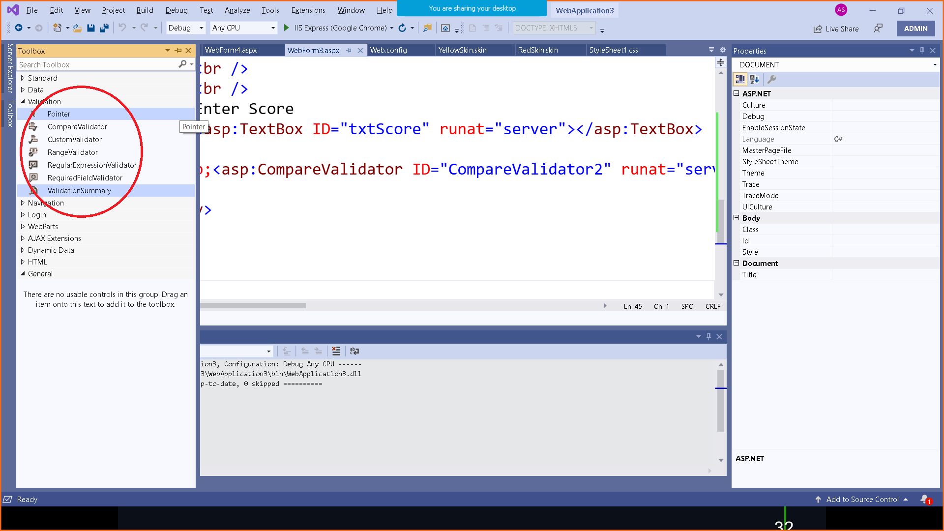

<%@ Page Language="C#" AutoEventWireup="true" CodeBehind="WebForm3.aspx.cs"

Inherits="WebApplication3.WebForm3" %>

<!DOCTYPE html>

<html xmlns="http://www.w3.org/1999/xhtml">

<head runat="server">

<title></title>

</head>

<body>

<form id="form1" runat="server">

<div>

Enter Name : <asp:TextBox ID="txtName" runat="server"></asp:TextBox>

<asp:RequiredFieldValidator ID="RequiredFieldValidator1" runat="server" ErrorMessage="*" ControlToValidate="txtName" ForeColor="Red"></asp:RequiredFieldValidator>

<asp:Button ID="btnSubmit" runat="server" Text="Submit" OnClick="btnSubmit_Click"></asp:Button>

<br />

<br />

Enter Age :

<asp:TextBox ID="txtAge" runat="server"></asp:TextBox>

&nbsp;

<asp:RequiredFieldValidator ID="RequiredFieldValidator2" runat="server" ErrorMessage="Age is Required" ControlToValidate="txtAge" Display="Dynamic"></asp:RequiredFieldValidator>

&nbsp;<asp:RangeValidator ID="RangeValidator1" runat="server" ControlToValidate="txtAge" Display="Dynamic" ErrorMessage="Age should be in Range 20 - 30" MaximumValue="30" MinimumValue="20"></asp:RangeValidator>

<br />

<br />

<br />

Enter Password :

<asp:TextBox ID="txtPasssord" runat="server"></asp:TextBox>

<asp:RequiredFieldValidator ID="RequiredFieldValidator3" runat="server" ControlToValidate="txtPasssord" ErrorMessage="Password is must"></asp:RequiredFieldValidator>

<br />

<br />

Retype Password : <asp:TextBox ID="txtReTupePassword" runat="server"></asp:TextBox>

<asp:RequiredFieldValidator ID="RequiredFieldValidator4" runat="server" ControlToValidate="txtReTupePassword" Display="Dynamic" ErrorMessage="Retype Password Again"></asp:RequiredFieldValidator>

&nbsp;<asp:CompareValidator ID="CompareValidator1" runat="server" ControlToCompare="txtPasssord" ControlToValidate="txtReTupePassword" Display="Dynamic" ErrorMessage="Password do not match"></asp:CompareValidator>

<br />

<br />

Enter Score

<asp:TextBox ID="txtScore" runat="server"></asp:TextBox>

&nbsp;<asp:CompareValidator ID="CompareValidator2" runat="server" ControlToValidate="txtScore" ErrorMessage="Score should be more than 30" Operator="GreaterThan" Type="Integer" ValueToCompare="30"></asp:CompareValidator>

</div>

</form>

</body>

</html>

protected void btnSubmit_Click(object sender, EventArgs e)

{

Response.Redirect("WebForm4.aspx");

}

WebForm4.aspx.cs

protected void Page_Load(object sender, EventArgs e)

{

Response.Write("Welcome to this Page");

}